Algebra 2 over 2 Years AB Name:__________________________
Midterm Review 2019–2020 Date: _______________Hour:______

The following topics will be assessed on the midterm.
Systems  of  Equations | Linear  Programming | Piecewise  Functions | Quadratic  Functions | Complex  Numbers | Circles
35% | 10% | 5% | 32% | 13% | 5%

Solve the following equations for the indicated variable.
- x – y = –4, for y | - $\frac{7A}{8B}=C$, for $C$ | - 6f – 7+ d = 28, for f

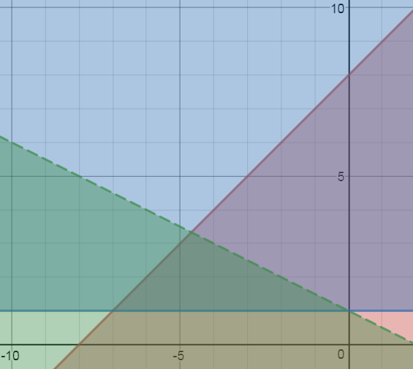
- Write all the constraints for the solution region.

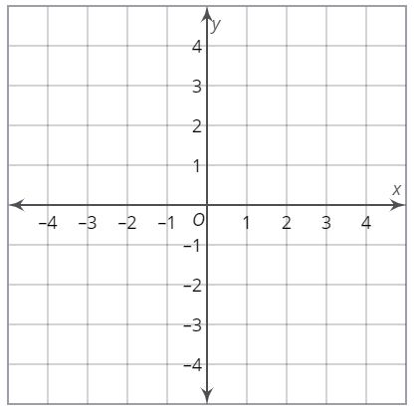
- Write and graph a system of inequalities whose
solution is only in Quadrants I and IV.

- Which of the following inequalities is NOT a constraint for the solution region?
a) 2x + y ≥ 10
b) x ≤ 10
c) x – y ≥ –7
d) 2x – y ≤ 2

- Sam needs to buy breakfast for his study group. The equation 0.80x + 1.50y < 12 models how much money he can spend on bagels and muffins. Let x = number of bagels and y = muffins. What do the following represent in the above inequality.

0.80x 1.50y 12 <

- Graph the inequality from the previous question.
Label each intercept with its ordered pair and tell
what it means in the context of the scenario.

- Consider Sam’s budget to buy bagels. What is one combination that will satisfy the inequality where the number of muffins is at least twice the number of bagels?

- A package delivery company is planning how to staff and route its delivery trucks.
In one week, the company will deliver at least 200 packages.
The company will deliver at least 150 envelopes.
The delivery company has the capacity to sort, ship and deliver no more than 850 packages and envelopes combined.

What are the constraints for this scenario?

- The Cougar Den sells hats for $12 and scarves for $15. The employees want to sell at least $240 of hats and scarves this season. Write and graph the inequality that will model this scenario.

- The theater department is selling tickets to the musical. The auditorium will hold 900 people. They must sell at least at least twice as many adult tickets as student tickets. They will not sell more than 800 adult tickets. The constraints and feasible region are shown.
If adult tickets are $15 and student tickets are $10, what is the maximum profit from ticket sales?
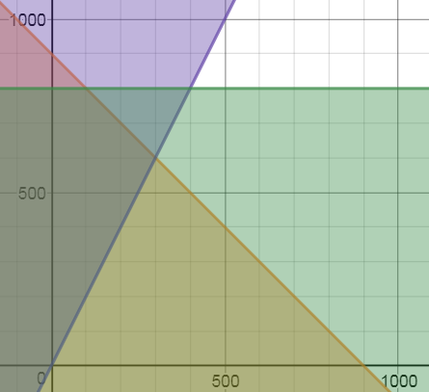

- Use the function f(x, y) = 3x + 4y to determine the maximum value of the feasible region.
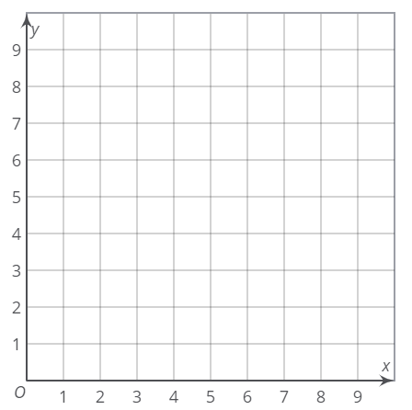

Solve the systems using either substitution or elimination (addition/subtraction).

- x – 4y = 8  x – y = –4 | - 12x + 5y = 45  12x + 5y = –5
- x = y – 5  5x + 3y = –9 | - y = 11x – 5  x – y = –5

- Fill in the missing portions of the piecewise function.
$$f\left(x\right)=\left\{\begin{aligned} ______________________, x ≤1 \\ \\ ______________________, x>1\end{aligned}\right.$$

Write the equation of each piecewise function.

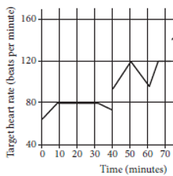
minutes
heart rate BPM
- On which interval(s) is John’s target heart rate constant? | - Write and graph a system whose solution is (1, 2).

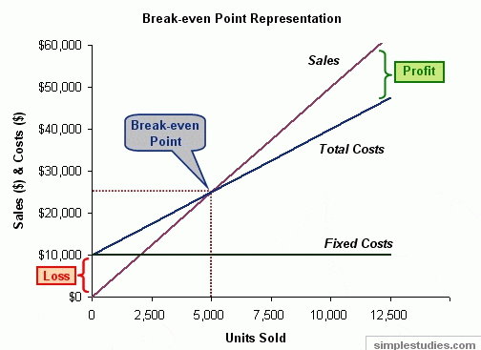
- The graph shows the comparison of expenses (cost) and income (sales) for a company that manufactures and sells toys. Assume the break–even point is (5000, $25000). Explain what a break–even point is and what does it mean in the context of this scenario.

- Consider the system of equations below. What multipliers would you use on both equations if you wanted to eliminate the variable y?
$$2x+5y=10 \\ 4x-3y=12$$

- Alex buys 6 Power Bars and 2 jars of Creatine for a total of $128.00. Niko buys just 2 Power Bars but buys 4 jars a Creatine for a total of $76.00. How much does each product cost?

- John has 20 meal coupons for McDonalds and Burger King.
McDonald’s coupons are worth $2 and Burger King’s coupons are worth $2.50.
He has a total of $44 worth of coupons, find the number of McDonald’s coupons John has.

- Write a system of equations, in slope intercept form, for each of the scenarios, and sketch a graph:
Exactly one solution No solution

Infinitely many solutions Exactly two solutions

- Determine if the ordered pairs fall in the solution set or not (yes or no).
a) (0, –2) __________
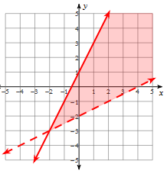
b) (0, 1) __________
c) (2, 1) __________
d) (4, 0) __________
e) (–2, –3) __________
f) (3, 4) __________

- Simplify $\sqrt{-200}$.

A. 2i$\sqrt{10}$ | B. –10i$\sqrt{2}$ | C. 10i$\sqrt{2}$ | D. –2i$\sqrt{10}$

- Simplify $\sqrt{-50}$ + $\sqrt{-18}$

- Simplify $\frac{ 3}{-2-5i}$ .
A. 2 + 5i | B. –2 + 5i | C. –2 – 5i | D. $\sqrt{-2-5i}$

- Simplify $\frac{ 10+3i}{5i}$ .

- Simplify 5(–4i)•( –2i) )•( 3i) )•( 5i)
- Simplify 5(–4i)•( –2i) )•( 3i) )

Simplify. YOU MUST SHOW ALL YOUR STEPS!
- (11 – 2i)(1 + 3i) | - (1 – 3i)(1 + 3i)

Use complete the square to write in vertex form.
- 2x² – 16x + 33 = 0. | - $x^{2}+10x+8=0$
Use complete the square or quadratic formula to find the exact solutions.
- $x^{2}+6x+7=0$ | - $x^{2}-3x+5=0$

- Find the sum of the solutions: 0= x² + 6x + 13.

- Find the absolute value of the difference of the solutions: 2x² –18x + 40.

Sketch the graph of the function. Then identify if it has one real solution, two real solutions or complex solutions.
- f(x) = –(x – 3)² + 5 | - f(x) = –(x – 4)²
- f(x) = (x – 6) + 1 | - f(x) = –(x – 7) – 1

- Which quadratic function(s) will have a range of y > 5?
A. f(x) = (x +5)² | B. f(x) = x² + 5 | C. f(x) = (x + 5)² + 5 | D. f(x) = –(x² – 5)

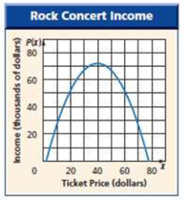
- Use the diagram about Rock Concert Income.

- If the vertex is at (40, 72), write an equation
that could model the graph. Use an a–value of $-\frac{1}{7}$.
- What is the range of the quadratic model shown in the diagram?

- A coin is dropped from the top of a building. The height of the coin as it falls is represented by the function h(t) = –16t² + 800 where h = height above the ground in feet and t = time in seconds.

- What is the time when the coin is at its maximum height? Explain how you know.

- What is the maximum height of the coin? Explain how you know.

- At what time will the coin hit the ground? Explain how you know.

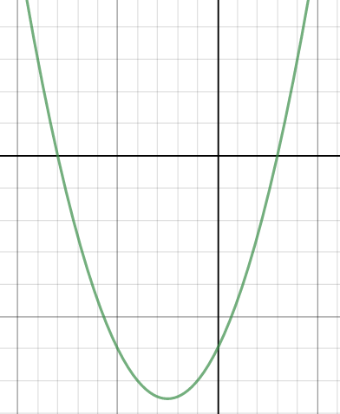
- Fill in the factors for the quadratic equation shown in the diagram.
f(x) = ( )( )
(-2, 0)
$$\left(\frac{3}{4}, 0\right)$$

- Which quadratic equation has roots 2 and ?
a. x² 4x 4 0 c. c. 5x² 9x 2 0
b. 5x² 9x 2 0 d. 5x² 11x 2 0

Solve the systems.
- $y=x^{2}-3x+2$  $$y=x+2$$ | - $y=x^{2}-5x+11$  $y=2x+1$

- Write 2 quadratic functions in vertex form. One that opens up and one that opens down that has a vertex at…
- (1, –7) | - (0, 3)

Sketch a graph of the each circle.
- ${(x-2)}^{2}+{(y+3)}^{2}=25$ | - $x^{2}+{(y-5)}^{2}=36$

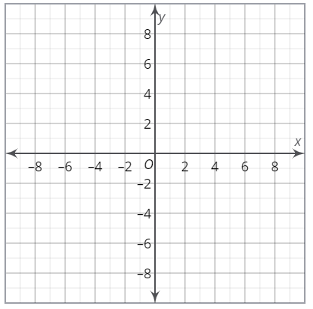

Use complete the square to write the standard form of the circles below.
- $x^{2}+12x+y^{2}-6y=4$ | - ${2x}^{2}-6x+y^{2}=4$

- Write the equation of a circle with center at (–6, –8) and radius of 10 units. Is the origin within the circle, on the circle or outside of the circle?

