Algebra 2 over 2 Years AB
Answer Key

- y = x + 4  - $A= \frac{8BC}{7}$  - $f=35-d$  - y > 1, y < $-\frac{1}{2}$x+1, y < x + 8  - see student answer  - b  - .80x is eighty cents, the price of bagels, multiplied by the number of bagels; 1.50y is the price of muffins multiplied by the number of muffins; $12 is the maximum Sam can spend; < tells you that what he spends must be les than $12.  - see graph  - 2 bagels and 1 muffin, 4 bagels and 2 muffins, or 6 bagels and 3 muffins are some possible answers  - x > 200, y > 150, x + y < 850  - 12x + 15y > 240, see graph  - $13,000  - 43  - (-8, 4)  - no solution  - (-3, 2)  - (1, 6)  - $f\left(x\right)=\left\{\begin{aligned}-\frac{1}{2}x+1.5, &x≤1 \\ -x+3, &x>1\end{aligned}\right.$  - $f\left(x\right)=\left\{\begin{aligned}3x+6, &x<-1 \\ -1, &x≥-1\end{aligned}\right.$  - $f\left(x\right)=\left\{\begin{aligned}x, &x≤0 \\ 2x, &x>0\end{aligned}\right.$  - 10 < x < 30  - see student answer  - Before the break-even point, the company is not making any profit because sales are less than costs. At the break-even point, sales have “caught up to” costs so they are equal. After the break-even point, the company starts to make money from the sale of the toy.  - There are infinitely many right answers for this question. The most common answer will probably be to multiply the first equation by 3 and the second equation by 5.  - $18 for Power Bars and $10 for a jar of Creatine  - 12 McDonald’s coupons and 8 Burger King coupons  - see student work, see student work, see student work, impossible  - no, yes, yes, no, no, yes  - C  - $8i\sqrt{2}$  - $\frac{-6+15i}{-25}$  - $\frac{3-10i}{5}$  - 600  - 120$i$  - 17 + 31$i$  - 10  - y = 2(x – 4)² + 1  - f(x) = (x + 5)² – 17  - -3 $±\sqrt{2}$  - 2$± i$  - -6  - 1  - 2 real solutions  - one real solution  - complex solutions  - complex solutions  - B and C  - y = $-\frac{1}{7}$(x – 40)² + 72, y < 72  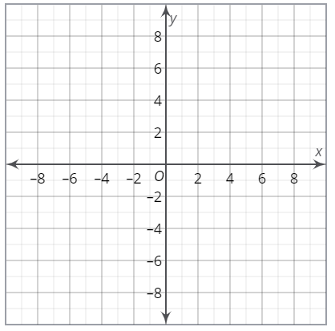  - 0 seconds, 800 feet, 7.07 seconds  - f(x) = (x + 2)(4x – 3)  - b  - {0, 4}  - {2, 5}  - y = (x – 1)² – 7, y = x² + 3  - see diagram  - see diagram  - (x + 6)² + (x – 3)² = 49  - (x – 2)² + y² = 6  - (x + 6)² + (y + 8)² = 10, on the circle | 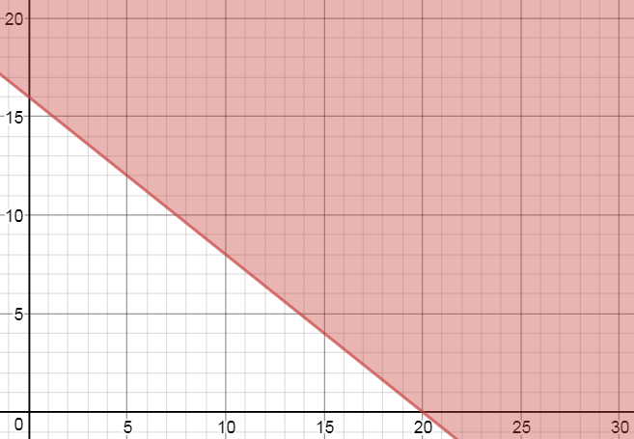  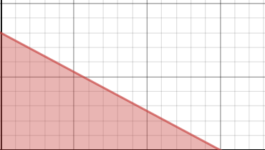  (15, 0)  (0, 8)

